|  |  |  |
| --- | --- | --- |
| République du Cameroun  ****** |  | Republic of Cameroon  ****** |
| Ministère de l’enseignement supérieur  ****** | Ministry of higher education  ****** |
| Paix-Travail-Patrie  ****** | Peace-Work-Fatherland  ****** |
| SAINT JEAN INGENIEUR  ****** | SAINT JEAN INGENIEUR  ****** |
| Academic year 2024-2025 | | |

**Group members:**

* ABENA ALEX NELSON RYAN
* AYUK NJIEASSAM MA-NDIEP
* CHAYONG TINDO CLAUDIA
* MFONE MBOUNGAM AHMAD AMINE

**Supervised by**

* ARTHUR PESSA
* EMMANUEL MOUPOJOU

**Title:**

Analysis document for BTP Sarl Construction Management Web Application

**EU Title**: ISI Transversal Project, Techdays

**EU code**: ING 3166

Table of Contents

Context 1

Introduction 1

Goals 1

Requirements Identification 2

A. Functional Requirements 2

B. Nonfunctional requirements 3

Use Cases Diagram 4

Use Case Descriptions 5

Approach being used for this design document 7

Conclusion 8

# Context

BTP Sarl is a company that manages and monitors construction projects. One of its main concerns is tracking the input and output of construction materials. The goal is to develop a web application that enables real-time traceability of construction project management and monitoring from tablets or computers. This project can be used in the field of civil engineering.

# Introduction

This analysis document aims to outline the design and implementation plan for a construction management system for BTP Sarl. The system will provide tools for tracking construction materials, managing financial transactions, and monitoring project progress. This document includes an overview of the goals, requirements, use cases, and the design approach for the web application.

# Goals

The primary goals of the construction management system are:

* To enable real-time monitoring of construction projects.
* To track the input and output of construction materials.
* To manage financial transactions related to construction projects.
* To provide project managers with tools for documenting and tracking project progress.
* To ensure easy management and assignment of users (project managers) by administrators.

# Requirements Identification

The system must fulfill the following requirements:

## Functional Requirements

1. **User Management:**
   * Administrators can create, update, and delete users.
   * Administrators can assign projects to project managers.
2. **Project Management:**
   * Administrators can create, update, and delete construction projects. Geographical information will be provided by an API to permit selection from a list of locations.
   * Project managers can view and manage assigned projects.
   * The system should support various project stages: Started, In Progress, Completed, and Cancelled.
3. **Material Management:**
   * Project managers can add, update, and delete construction materials.
   * The system tracks the quantity of materials in stock.
   * The system supports the import of materials from an Excel file.
   * Materials can be filtered and viewed based on availability.
4. **Transaction Management:**
   * Project managers can record financial transactions (input/output).
   * The system links the cash register with material stock management.
   * The Administrator will be able to confirm transaction or material requests made by project managers.
   * The system tracks financial transactions related to material purchases and rentals. The transaction log can be consulted by the project manager and the administrator.
5. **Construction Work Monitoring:**
   * Project managers can take photos using the device's camera.
   * Project managers can associate text descriptions with photos and assign a progress score to projects.
   * Photos are stored in a gallery accessible via the application by the administrator.

## Nonfunctional requirements

* The system must be accessible via web browsers on tablets and computers.
* The user interface must be ergonomic, simple, and intuitive.
* The system should be scalable and reliable.

# Use Cases Diagram

Below is the use case diagram and descriptions for the main functionalities of the system.

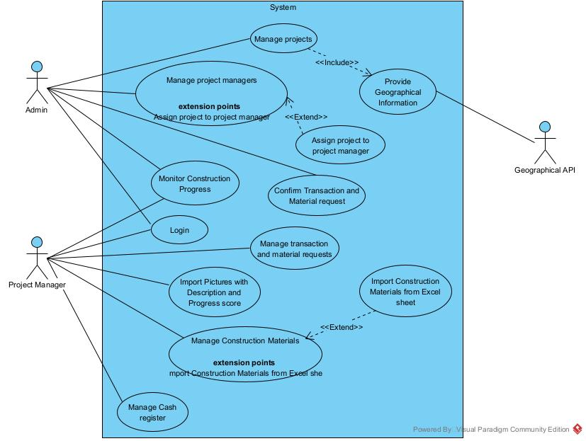

Figure 1: Use case diagram for the BTP Project

# Use Case Descriptions

**Administrators:**

* The administrators manage the construction sites that is he adds, deletes or modifies a construction site.
* The administrators manage project managers that is he adds, modifies or removes them.
* The administrators assign a project manager to a construction site.
* The administrators view all the project managers’ dashboards.
* The administrator can login to his account.

**Project Manager:**

* The project manager manages the construction materials which are in the stock that is he adds or removes a material from the stock.
* The project manager controls the input and output of cash in the cash register.
* The project manager imports a list of construction materials from a Microsoft Excel file.
* The project manager manages requests for building materials either by accepting or rejecting the request.
* The project manager can filter the materials and equipment based on certain criteria like the nature of the material or the providers.
* The project manager consults the list of construction materials in order to see the availability and lack of some specific materials.
* The project manager monitors the inflow and outflow of materials and makes sure that they are used correctly, for the correct purpose and in the right amounts
* The project manager keeps tracks of the entry and exit of equipment from the warehouse to the different workers and back to the warehouse or from a provider to the workers and back.
* The project manager uploads a picture indicating the progress of a specific task of the construction site which helps to give an overview of the progression of the entire construction site.
* A project manager can login into his account.

**Geographical API:**

* The geographical API will be responsible of providing location information to eliminate inconsistency in location spelling during project creation or editing.

# Approach being used for this design document

We will use the 4+1 methodology for our design.

## Description of the methodology.

The **4+1 View Model** is a software architecture methodology that uses five complementary views to describe a system. The **Logical View** (Class Diagram) focuses on the static structure of classes and their relationships. The **Process View** (Sequence Diagram) captures dynamic interactions between objects over time. The **Development View** (Activity Diagram) represents workflows and processes, while the **Physical View** (Deployment Diagram) shows how software components are deployed on hardware. The **Scenarios (+1)** (Use Case Diagram) ties everything together through real-world use cases. Below is a summary table:

| **View** | **Diagram** | **Purpose** |
| --- | --- | --- |
| **Logical View** | Class Diagram | Shows the static structure of classes and their relationships. |
| **Process View** | Sequence Diagram | Shows dynamic interactions between  objects over time. |
| **Development View** | Activity Diagram | Represents workflows and processes in  the system. |
| **Physical View** | Deployment Diagram | Shows how software components are  deployed on hardware. |
| **Scenarios (+1)** | Use Case/Sequence | Validates the architecture by showing  how the system behaves in scenarios. |

**NB**: In our case the deployment diagram will be replaced by the State transition diagram because we unfortunately.

# Conclusion

The analysis document provides a comprehensive basis for the production of the web application that will address BTP Sarl’s management need. By focusing on real time traceability and secure transaction management the proposed system will significantly improve efficiency and project control.